**DESCRIPTION**

**I/ Home Page:**

**1/ Main Menu:** Home page shows Logo of Star Organic company, navigation to other pages like: Product Page, Gallery Page, About Page and Contact Page.



**2/ Slide Show:** Slideshow represent some colorful images of organic products, that will automatically change from one to another or by choosing the navigation arrows beside the image.

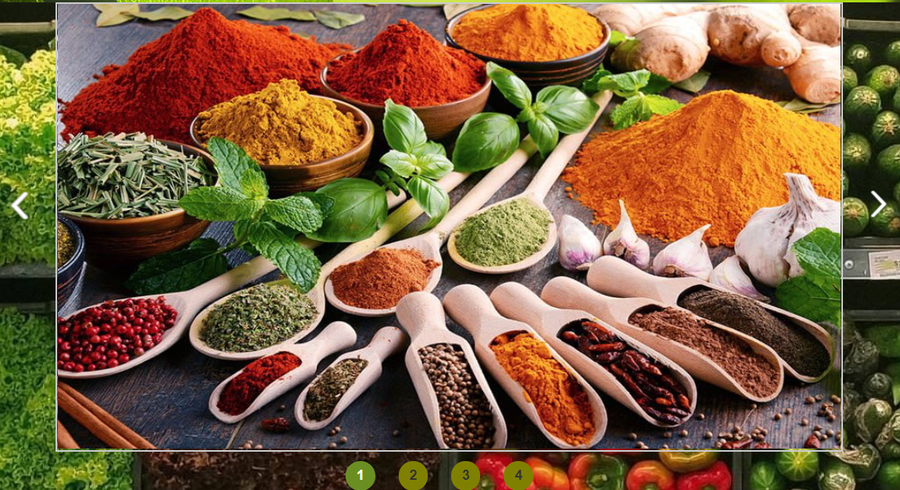

**3/Grids of Organic Products:** in this section, some feature Poroducts will be display as Grid of Product. Each image of the product can be linked to the Product detail page.

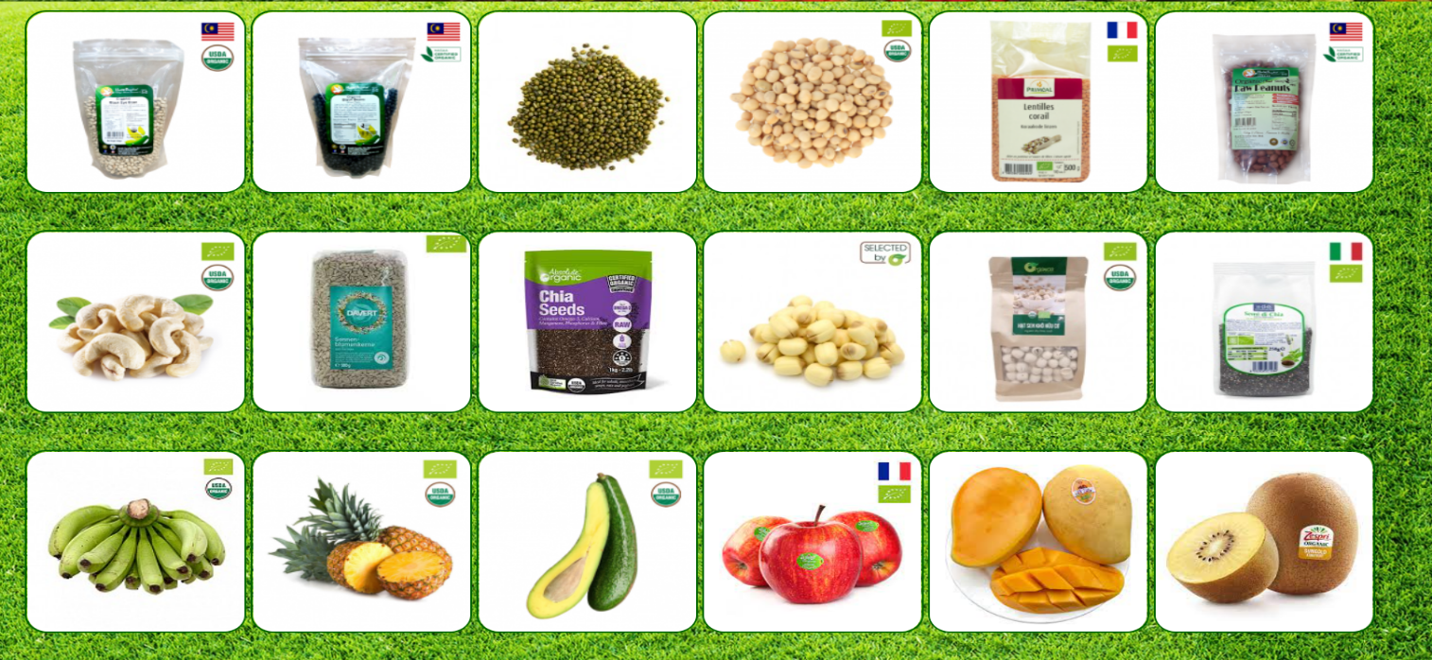

4/ **The Footer:** At the end of the page, is the location of footer section. In this section, you will can access to other pages by Quick Links, or you can go to Contact Page by choosing the Location. Beside, you can follow us on Facebook, Tweeter, etc by cliking mouse on the appreciate icon on Follow Us section.

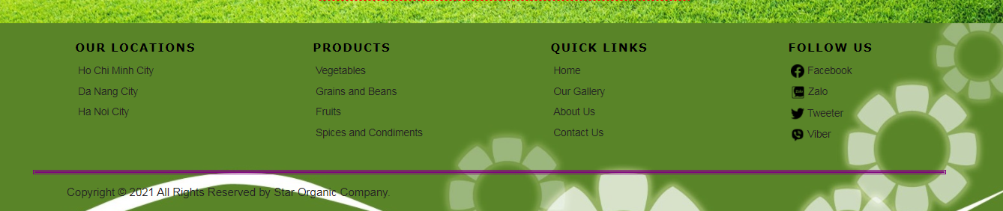

**II/** **Product pages:**

**1/Main Menu:** This is the Main Menu, that is the same for all Page. In this Menu, we can access all of other pages like: Home, Product, Gallery, About us and Contact us.



**2/Product’s Image:** in this section, there is an image that is used to illutrate the product in main section.

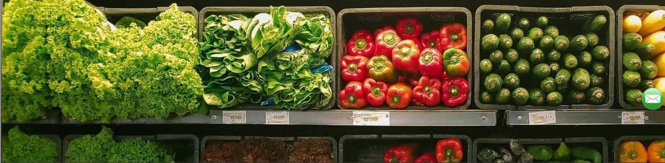

**3/Product’s Menu:** in this section, you can find 4 kinds of producs like: vegetable, grain, fruit anf spices. Ths menu is dsplayed as a SideBar, where you can navigate to each kind of the product: Vegetable, grain, Fruit anf Spices.

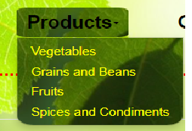

# Product: In here you will find a lot of organic products that are very good for health, And I assure you that here we always sell the best and cheapest products on the market. Simply because we always put health first. We believe you will buy 2nd and 3rd times.... when you buy this product once in our store. If you want to know more uses, quality, price or click on them.

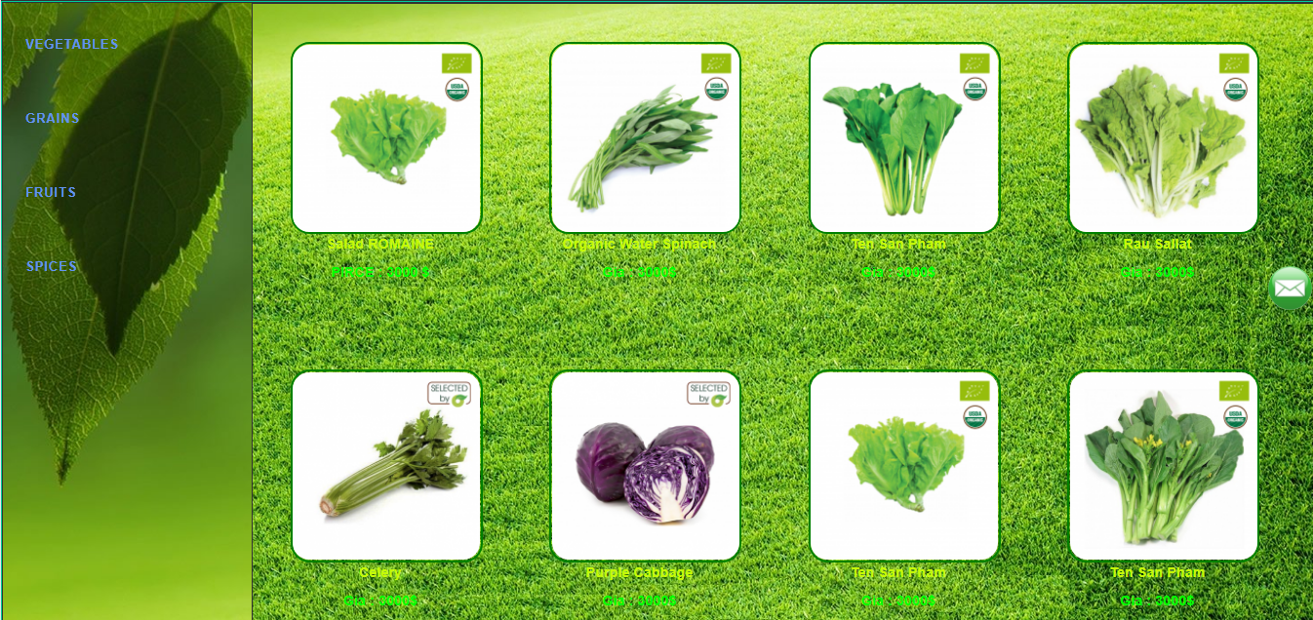

**4/ The Footer:** At the end of the page, is the location of footer section. In this section, you will can access to other pages by Quick Links, or you can go to Contact Page by choosing the Location. Beside, you can follow us on Facebook, Tweeter, etc by cliking mouse on the appreciate icon on Follow Us section.



**III. Detail pages: Product**

**1/Main Menu:** This is the Main Menu, that is the same for all Page. In this Menu, we can access all of other pages like: Home, Product, Gallery, About us and Contact us.



**2/Product’s Image:** in this section, there is an image that is used to illutrate the product in main section.



**3/ Detail Product:** in this but the information you want to know about the product is already here about product information including product price, origin, quantity, and one more thing, we always let customers rate and comment. to let you know and understand how the product is here and also partly for us to know and for a quick fix. Here you can add to the package for your convenience for a one-time payment. Thank you for watching and don't forget to leave a comment and review so we can always have a better product for you.

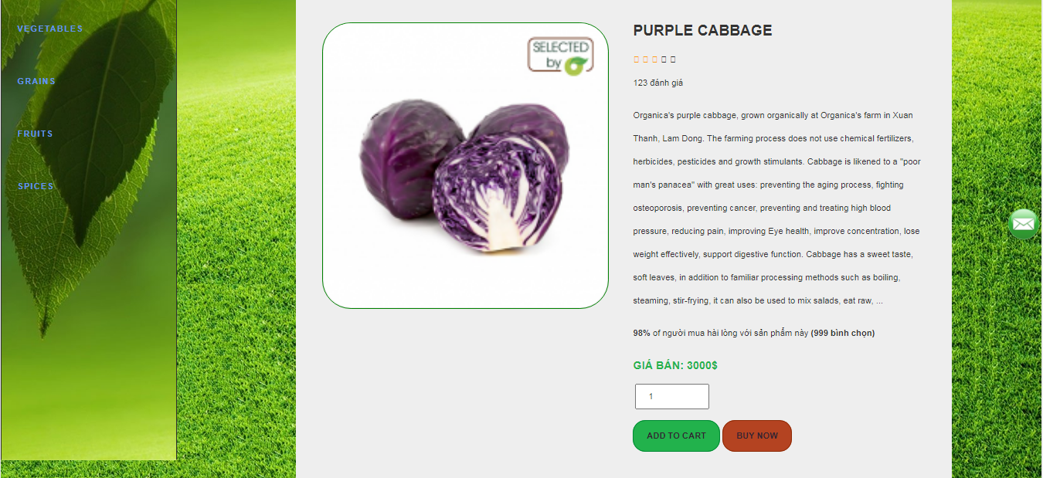

**4/ The Footer:** At the end of the page, is the location of footer section. In this section, you will can access to other pages by Quick Links, or you can go to Contact Page by choosing the Location. Beside, you can follow us on Facebook, Tweeter, etc by cliking mouse on the appreciate icon on Follow Us section.



**IV/Gallery page:** Gallely Page will show the Logo-attached Menu bar; the grid of recipes with their legends and the Footer with Quick Links, Locations and Fanpage on Facebook, Tweeter, etc…This page has 3 sections as below:

**1/ Main Menu**: This is the Main Menu, that is the same for all Page. In this Menu, we can access all of other pages like: Home, Product, Gallery, About us and Contact us. IBelow the Menu is the Title of the Gallery: the Organic Recipes. Follow the Title is the short Summary about the Organic Recipes.

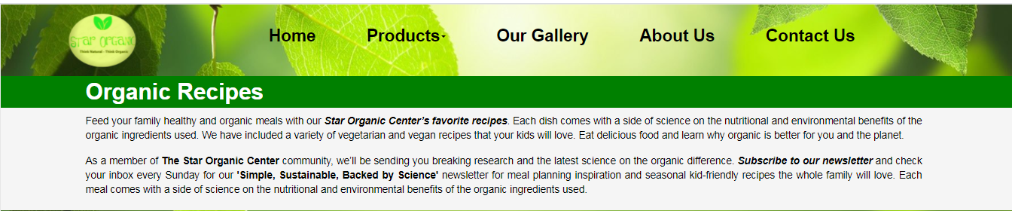

**2/Grid of the Recipes:** Follow by the Title is the Main Section of the page. In this section, we will show 12 best Organic Recipes. All of them are organised as a Grids, so you can easily choose which of the reripes you want. Besides, you can choose either one of the images of the grid or the images’ legend to open the the detail page of that recipe.

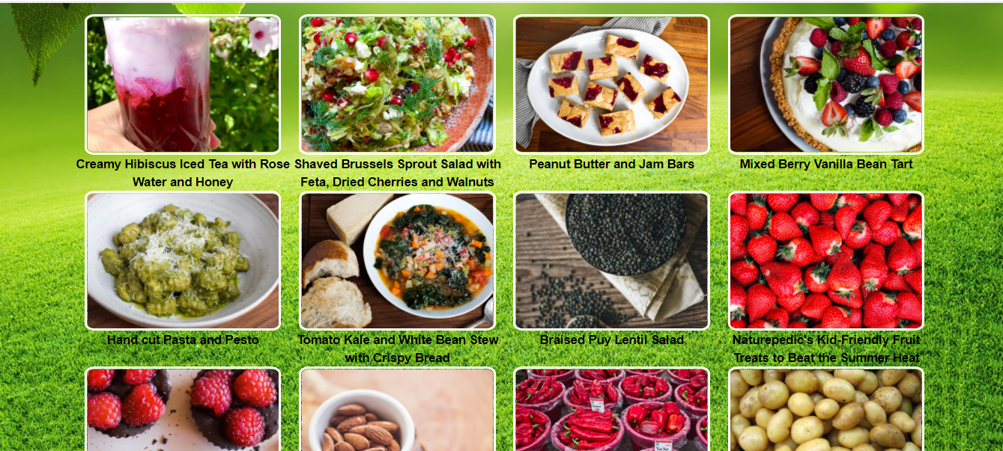

**3/ The Footer:** At the end of the page, is the location of footer section. In this section, you will can access to other pages by Quick Links, or you can go to Contact Page by choosing the Location. Beside, you can follow us on Facebook, Tweeter, etc by cliking mouse on the appreciate icon on Follow Us section.

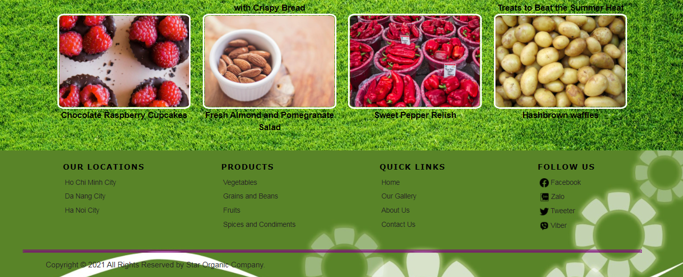

**V/ Detail Gallery Page:**

**1/ Main Menu**: This is the Main Menu, that is the same for all Page. In this Menu, we can access all of other pages like: Home, Product, Gallery, About Us and Contact Us.



**2/ The detail information abour the Recipe:** in this, sectiom, you will find the detail guideline to have a delicious meal by yourself. This section include: the scientific information of the recipe, the recipe, ingredients and instructions.

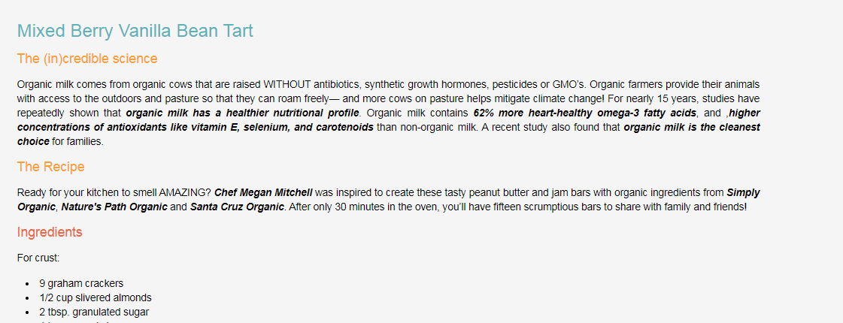

**3/ The Footer:** At the end of the page, is the location of footer section. In this section, you will can access to other pages by Quick Links, or you can go to Contact Page by choosing the Location. Beside, you can follow us on Facebook, Tweeter, etc by cliking mouse on the appreciate icon on Follow Us section.



**VI/ Feedback Page:**

**1/ Main Menu**: This is the Main Menu, that is the same for all Page. In this Menu, we can access all of other pages like: Home, Product, Gallery, About us and Contact us.



**2/ Feedback for:** Below the Menu is the Form of the Feedback. In the Form, you have to give us som information about you like: your name, your emal, your email and the subject that you need us to answer.

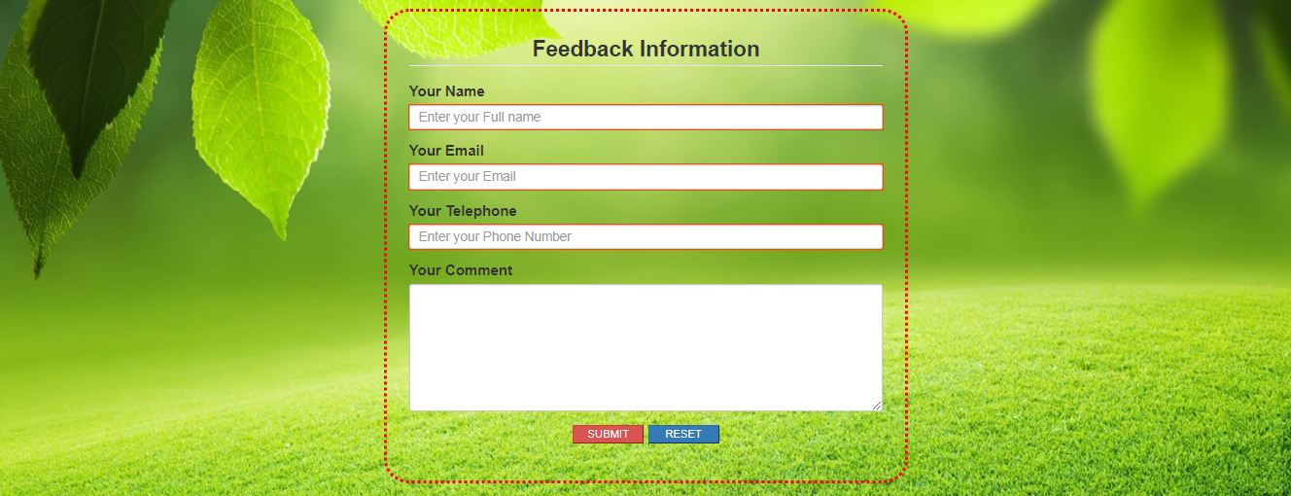

**3/ The Footer:** At the end of the page, is the location of footer section. In this section, you will can access to other pages by Quick Links, or you can go to Contact Page by choosing the Location. Beside, you can follow us on Facebook, Tweeter, etc by cliking mouse on the appreciate icon on Follow Us section.



**VII/Contact Us page:**

**1/ Main Menu**: This is the Main Menu, that is the same for all Page. In this Menu, we can access all of other pages like: Home, Product, Gallery, About us and Contact us.

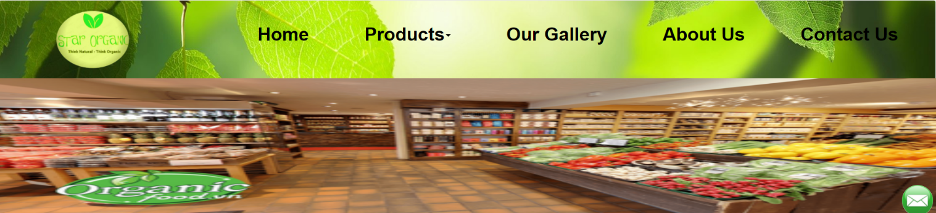

**2/Store Information:**Includes 3 stores and locations of stores with customer feedback 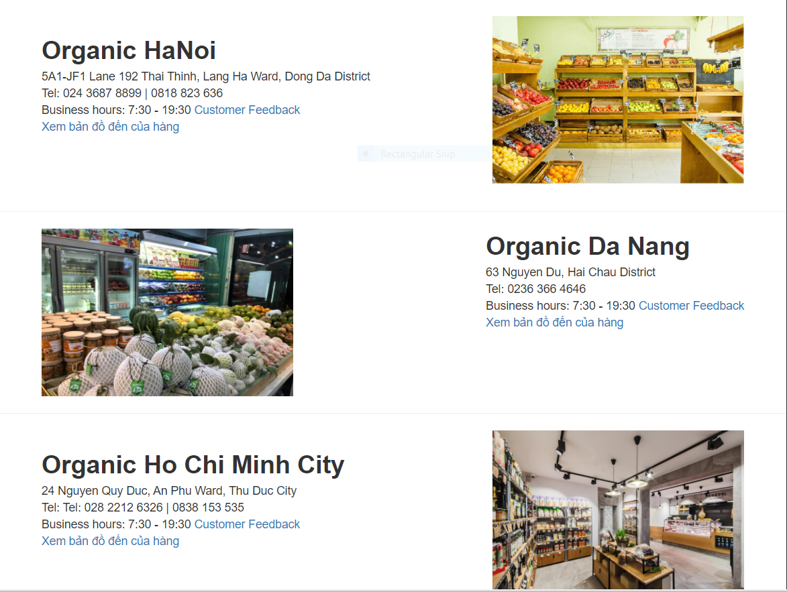

**3/ The Footer:** At the end of the page, is the location of footer section. In this section, you will can access to other pages by Quick Links, or you can go to Contact Page by choosing the Location. Beside, you can follow us on Facebook, Tweeter, etc by cliking mouse on the appreciate icon on Follow Us section.



**VIII/About Us page:**

**1/ Main Menu**: This is the Main Menu, that is the same for all Page. In this Menu, we can access all of other pages like: Home, Product, Gallery, About us and Contact us.



**2/INTRODUCING ABOUT COMPANY:**includes about company introduction and food, farm, company formation.

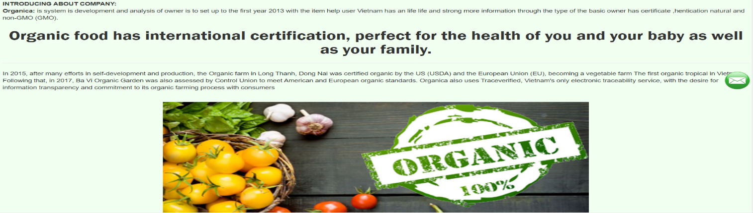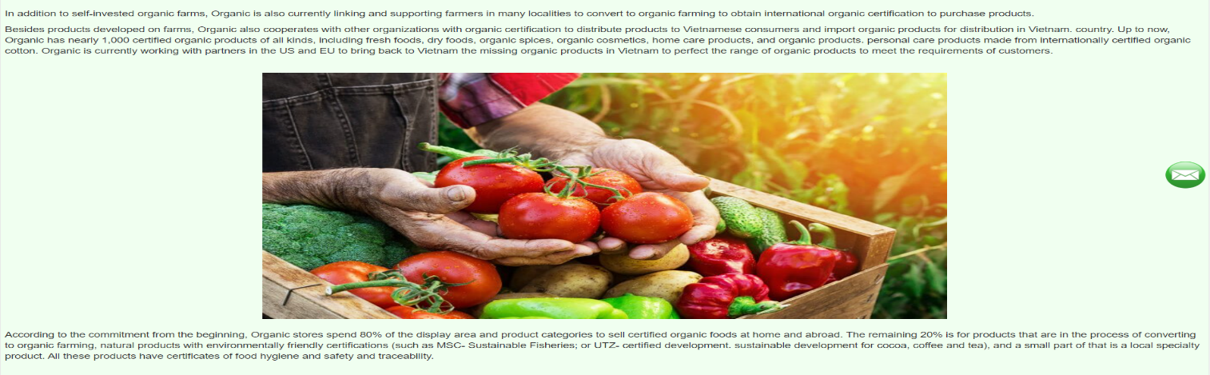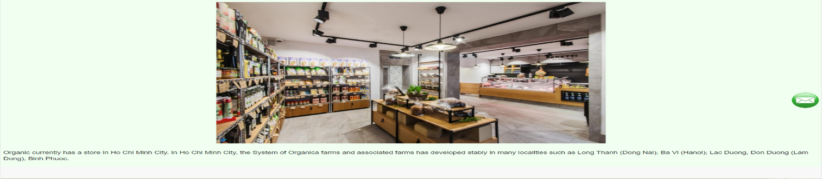

**3/The Footer:** At the end of the page, is the location of footer section. In this section, you will can access to other pages by Quick Links, or you can go to Contact Page by choosing the Location. Beside, you can follow us on Facebook, Tweeter, etc by cliking mouse on the appreciate icon on Follow Us section.

